1.
a) Outline the steps needed in the design process of a network.
(10 marks)

b) What FACTORS would need to be taken into account in the capacity planning of a new network?
(15 marks)
c) What are the advantages and disadvantages of designing networks for:

i) greenfield sites and
ii) existing sites?

  - Explain the following in relation to networks
    - What is meant by a Minimum Spanning Tree and why is it important?
    - Why is Krusgal’s algorithm known as a greedy algorithm?
    - What are the three steps to Prim’s algorithm for determining the MST?
(12 Marks)

  - Below is a network: Use Kruskal’s Algorithm to determine an MST for
this network, and state its length. Show the order in which you select and reject edges.

(12 marks)

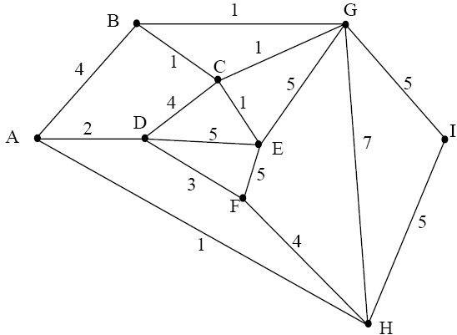
Graph 1

d) If the edge {G, H} must be included in your solution to part (a) above, what is the length of the new MST for this network?
(5 marks)

